CHAPTER -1
INTRODUCTION
1.1 EMBEDDED SYSTEM:

An embedded system is a special-purpose system in which the computer is completely encapsulated by or dedicated to the device or system it controls. Unlike a general-purpose computer, such as a personal computer, an embedded system performs one or a few predefined tasks, usually with very specific requirements. Since the system is dedicated to specific tasks, design engineers can optimize it, reducing the size and cost of the product. Embedded systems are often mass-produced, benefiting from economies of scale.
Personal digital assistants (PDAs) or handheld computers are generally considered embedded devices because of the nature of their hardware design, even though they are more expandable in software terms. This line of definition continues to blur as devices expand. With the introduction of the OQO Model 2 with the Windows XP operating system and ports such as a USB port — both features usually belong to "general purpose computers", — the line of nomenclature blurs even more.
Physically, embedded systems ranges from portable devices such as digital watches and MP3 players, to large stationary installations like traffic lights, factory controllers, or the systems controlling nuclear power plants.

In terms of complexity embedded systems can range from very simple with a single microcontroller chip, to very complex with multiple units, peripherals and networks mounted inside a large chassis or enclosure.

Embedded systems are unique in several ways, as described above. When designing embedded systems, there are several categories of requirements that should be considered:
. Embedded systems can also be thought of as information processing subsystems integrated in a larger system. As part of a larger system it largely determines its functionality.

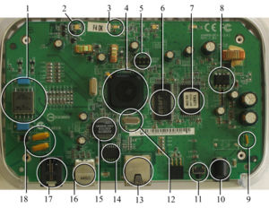

Fig 1.1 ES model
Examples of Embedded Systems:
- Avionics, such as inertial guidance systems, flight control hardware/software and other integrated systems in aircraft and missiles
- Cellular telephones and telephone switches
- Engine controllers and antilock brake controllers for automobiles
- Home automation products, such as thermostats, air conditioners, sprinklers, and security monitoring systems
- Handheld calculators
- Handheld computers
- Household appliances, including microwave ovens, washing machines, television sets, DVD players and recorders
- Medical equipment
- Personal digital assistant
- Videogame consoles
- Computer peripherals such as routers and printers.
- Industrial controllers for remote machine operation.

1.2 Block Diagram:

LCD

LPC 2148
POWER SUPPLY

Vibration sensor
MOTOR DRIVER
DC MOTOR
Alcohol sensor

MAX232
GSM
FIRE sensor

IR sensor

GPS
MAX232

BUZZER

FIG 1.2Block diagram

1.2.1 Block Diagram:

micro-controller:
In this project work the micro-controller is plays major role. Micro-controllers were originally used as components in complicated process-control systems. However, because of their small size and low price, Micro-controllers are now also being used in regulators for individual control loops. In several areas Micro-controllers are now outperforming their analog counterparts and are cheaper as well.
Power supply:
In this project we required operating voltage for ARM controller board is 12V. Hence the 12V D.C. power supply is needed for the ARM board. This regulated 12V is generated by stepping down the voltage from 230V to 18V now the step downed a.c voltage is being rectified by the Bridge Rectifier using 1N4007 diodes. The rectified a.c voltage is now filtered using a ‘C’ filter. Now the rectified, filtered D.C. voltage is fed to the Voltage Regulator. This voltage regulator provides/allows us to have a Regulated constant Voltage which is of +12V. The rectified; filtered and regulated voltage is again filtered for ripples using an electrolytic capacitor 100μF. Now the output from this section is fed to microcontroller board to supply operating voltage.
LCD: LCD is used to display the information about the current process.
MAX 232 Sections:
The microcontroller can communicate with the serial devices using its single Serial Port. The logic levels at which this serial port operates is TTL logics. But some of the serial devices operate at RS 232 Logic levels. For example PC and GSM etc. So in order to communicate the Microcontroller with either GSM modem or PC, a mismatch between the Logic levels occurs. In order to avoid this mismatch, in other words to match the Logic levels, a Serial driver is used. And MAX 232 is a Serial Line Driver used to establish communication between microcontroller and PC (or GSM).

DC Motor:
DC motor is an output for this project. And DC motor is connected to microcontroller. And this motor controlled by the microcontroller with the respective inputs given by us. Its speed will be varied according to the speed set by the switches.
ZIGBEE:
ZIGBEE is new wireless technology guided by IEEE 802.15.4 Personal Area Network standard. It is primarily designed for the wide ranging controlling applications and to replace the existing non-standard technologies. It currently operates in 868MHz band at a data rate of 20Kbps in Europe, 914MHz band at 40kbps in USA, and the 2.4GHz ISM bands Worldwide at a maximum data-rate of 250kbps.
Driver circuit:
L293D is a dual H-bridge motor driver integrated circuit (IC). Motor drivers act as current amplifiers since they take a low-current control signal and provide a higher-current signal. This higher current signal is used to drive the motors.
IR SENSOR
Infrared is an energy radiation with a frequency below our eyes sensitivity, so we cannot see it Even that we cannot "see" sound frequencies, we know that it exist, we can listen them.

Fig 1.3 IR Sensors
Even that we cannot see or hear infrared, we can feel it at our skin temperature sensors.
When you approach your hand to fire or warm element, you will "feel" the heat, but you can't see it. You can see the fire because it emits other types of radiation, visible to your eyes, but it also emits lots of infrared that you can only feel in your skin.
GSM
Global System for Mobile (GSM) is a second generation cellular standard developed to cater voice services and data delivery using digital modulation
GSM-History
• Developed by Group Special Mobile (founded 1982) which was an initiative ofCEPT (Conference of European Post and Telecommunication)
• Aim: to replace the incompatible analog system
• Presently the responsibility of GSM standardization resides with special mobile
GPS
The Global Positioning System (GPS) is a space-based satellite navigation system that provides location and time information in all weather, anywhere on or near the Earth, where there is an unobstructed line of sight to four or more GPS satellites. It is maintained by the United States government and is freely accessible to anyone with a GPS receiver.
The GPS program provides critical capabilities to military, civil and commercial users around the world. In addition, GPS is the backbone for modernizing the global air traffic system.
The GPS project was developed in 1973 to overcome the limitations of previous navigation systems, ^{[1]} integrating ideas from several predecessors, including a number of classified engineering design studies from the 1960s. GPS was created and realized by the U.S. Department of Defense (DoD) and was originally run with 24 satellites. It became fully operational in 1994.
Group under ETSI (European telecommunication Standards Institute)
Full set of specifications phase-I became available in 1990
• Under ETSI, GSM is named as “Global System for Mobile communication “
• Today many providers all over the world use GSM (more than 135Countries in Asia, Africa, Europe, America)
• More than 1300 million subscribers in world and 45 million subscribers in India.
The Global Positioning System (GPS) is a space-based satellite navigation system that provides location and time information in all weather, anywhere on or near the Earth, where there is an unobstructed line of sight to four or more GPS satellites. It is maintained by the United States government and is freely accessible to anyone with a GPS receiver.
The GPS program provides critical capabilities to military, civil and commercial users around the world. In addition, GPS is the backbone for modernizing the global air traffic system.
The GPS project was developed in 1973 to overcome the limitations of previous navigation systems, ^{[1]} integrating ideas from several predecessors, including a number of classified engineering design studies from the 1960s. GPS was created and realized by the U.S. Department of Defense (DoD) and was originally run with 24 satellites. It became fully operational in 1994.
Advances in technology and new demands on the existing system have now led to efforts to modernize the GPS system and implement the next generation of GPS III satellites and Next Generation Operational Control System (OCX).^{[2]} Announcements from the Vice President and the White House in 1998 initiated these changes. In 2000, U.S. Congress authorized the modernization effort, referred to as GPS III.

CHAPTER- 2
HARDWARE COMPONENTS
2.1 Microcontroller (LPC 2148):
ARM stands for Advanced RISC Machines. It is a 32 bit processor core, used for high end application. It is widely used in Advanced Robotic Applications.
History and Development:
- ARM was developed at AcronComputers ltd of Cambridge, England between 1983 and 1985.
- RISC concept was introduced in 1980 at Stanford and Berkley.
- ARM ltd was found in 1990.
- ARM cones are licensed to partners so as to develop and fabricate new microcontrollers around same processor cores.
Key features:
- 16-bit/32-bit ARM7TDMI-S microcontroller in a tiny LQFP64 package.
- 8 kB to 40 kB of on-chip static RAM and 32 kB to 512 kB of on-chip flash memory.
- 128-bit wide interface/accelerator enables high-speed 60 MHz operation.
- In-System Programming/In-Application Programming (ISP/IAP) via on-chip boot loader software. Single flash sector or full chip erase in 400 ms and programming of 256 bytes in 1 ms.
- Embedded ICE RT and Embedded Trace interfaces offer real-time debugging with the on-chip Real Monitor software and high-speed tracing of instruction execution.
- USB 2.0 Full-speed compliant device controller with 2 kB of endpoint RAM.
- In addition, the LPC2146/48 provides 8 kB of on-chip RAM accessible to USB by DMA.
- One or two (LPC2141/42 vs. LPC2144/46/48) 10-bit ADCs provide a total of 6/14 analog inputs, with conversion times as low as 2.44 μs per channel.
- Single 10-bit DAC provides variable analog output (LPC2142/44/46/48 only).
- Two 32-bit timers/external event counters (with four capture and four compare channels each), PWM unit (six outputs) and watchdog.
- Low power Real-Time Clock (RTC) with independent power and 32 kHz clock input.
- Multiple serial interfaces including two UARTs (16C550), two Fast I2C-bus (400 Kbit/s),
- SPI and SSP with buffering and variable data length capabilities.
- Vectored Interrupt Controller (VIC) with configurable priorities and vector addresses.
- Up to 45 of 5 V tolerant fast general purpose I/O pins in a tiny LQFP64 package.
- Up to 21 external interrupt pins available.
- 60 MHz maximum CPU clock available from programmable on-chip PLL with settling time of 100 μs.
- On-chip integrated oscillator operates with an external crystal from 1 MHz to 25 MHz
- Power saving modes include idle and Power-down.
2.1.1 LPC2148 block Diagram
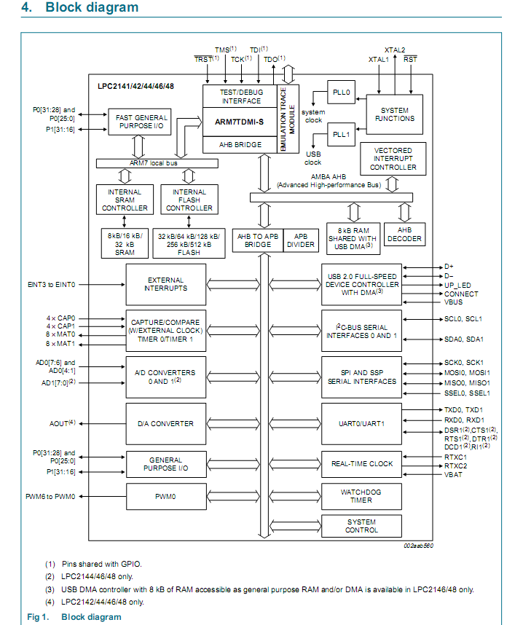
Fig 2.1 LPC 2148 block diagram
2.2 History and Development
- ARM was developed at Acron Computers ltd of Cambridge, England between 1983 and 1985.
- RISC concept was introduced in 1980 at Stanford and Berkley.
- ARM ltd was found in 1990.
- ARM cores are licensed to partners so as to develop and fabricate new microcontrollers around same processor cores.

Core Data path
- Architecture is characterized by Data path and control path.
- Data path is organized in such a way that, operands are not fetched directly from memory locations. Data items are placed in register files. No data processing takes place in memory locations.
- Instructions typically use 3 registers. 2 source registers and 1 destination register.
Barrel Shifter preprocesses data, before it enters ALU.
- Barrel Shifter is basically a combinational logic circuit, which can shift data to left or right by arbitrary number of position in same cycle.
Increment or Decrement logic can update register content for sequential access.

Pipeline
In ARM 7, a 3 stage pipeline is used. A 3 stage pipeline is the simplest form of pipeline that does not suffer from the problems such as read before write. In a pipeline, when one instruction is executed, second instruction is decoded and third instruction will be fetched .This is executed in a single cycle.

Register Bank
- ARM 7 uses load and store Architecture.
- Data has to be moved from memory location to a central set of registers.
- Data processing is done and is stored back into memory.
- Register bank contains, general purpose registers to hold either data or address.
- It is a bank of 16 user registers R0-R15 and 2 status registers.
- Each of these registers is 32 bit wide.

Data Registers- R0-R15
R0-R12 - General Purpose Registers
R13-R15 - Special function registers of which,
R13 - Stack Pointer, refers to entry pointer of Stack.
R14 - Link Register, Return address is put to this whenever a subroutine is called.
R15 - Program Counter
Depending upon application R13 and R14 can also be used as GPR. But not commonly used.

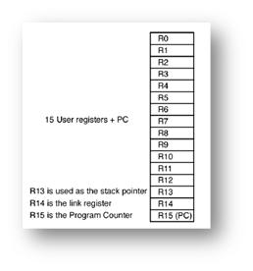
Fig 2.2 data register
In addition there are 2 status registers
- CPSR - Current program status register, status of current execution is stored.
- SPSR - Saved program Status register, includes status of program as well as processor.
CPSR
CPSR contains a number of flags which report and control the operation of ARM7 CPU.
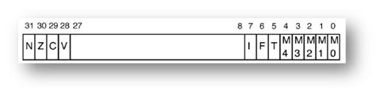
FIG 2.3CPSR register
Conditional Code Flags
N - Negative Result from ALU
Z - Zero result from ALU
C - ALU operation carried out
V - ALU operation overflowed

Interrupt Enable Bits
I - IRQ, Interrupt Disable
F - FIQ, Disable Fast Interrupt

T- Bit
If
T=0, Processor in ARM Mode.
T=1, Processor in THUMB Model

Mode Bits
Specifies the processor Modes. Processor Modes will be discussed in the next part of this tutorial.

ARM features
- Barrel Shifter in data path that maximize the usage of hardware available on the chip.
- Auto increment and Auto decrement addressing modes to optimize program loop. This feature is not common in RISC architecture.
- Load and Store instruction to maximize data throughput.
- Conditional execution of instructions, to maximize execution throughput.
Vectored Interrupt Controller (VIC)
Features:
- ARM Prime Cell™ Vectored Interrupt Controller
- 32 interrupt request inputs
- 16 vectored IRQ interrupts
- 16 priority levels dynamically assigned to interrupt requests
- Software interrupt generation
Description:
Register description:
The Vectored Interrupt Controller (VIC) takes 32 interrupt request inputs and programmable assigns them into 3 categories, FIQ, vectored IRQ, and non-vectored IRQ The programmable assignment scheme means that priorities of interrupts from the various peripherals can be dynamically assigned and adjusted. Fast Interrupt request (FIQ) requests have the highest priority.
Universal asynchronous Receiver/Transmitter 0:
Features:
- 16 byte Receive and Transmit FIFOs
- Register locations conform to ‘550 industry standard
- Receiver FIFO trigger points at 1, 4, 8, and 14 bytes
- Built-in fractional baud rate generator with auto bonding capabilities.
- Mechanism that enables software and hardware flow control implementation

Pin description:

Register description:

Architecher:
The VPB interface provides a communications link between the CPU or host and the UART0.

The UART0 receiver block, U0RX, monitors the serial input line, RXD0, for valid input. The
UART0 RX Shift Register (U0RSR) accepts valid characters via RXD0. After a valid character
Is assembled in the U0RSR, it is passed to the UART0 RX Buffer Register FIFO to await access by the CPU or host via the generic host interface. The UART0 transmitter block, U0TX, accepts data written by the CPU or host and buffers the data in the UART0 TX Holding Register FIFO (U0THR). The UART0 TX Shift Register (U0TSR) reads the data stored in the U0THR and assembles the data to transmit via the serial output pin, TXD0
The UART0 Baud Rate Generator block, U0BRG, generates the timing enables used by the UART0 TX block. The U0BRG clock input source is the VPB clock (PCLK). The main clock is divided down per the divisor specified in the U0DLL and U0DLM registers. This divided down clock is a 16x oversample clock, NBAUDOUT.
The interrupt interface contains registers U0IER and U0IIR. The interrupt interface receives several one clock wide enables from the U0TX and U0RX blocks
Status information from the U0TX and U0RX is stored in the U0LSR. Control information for the U0TX and U0RX is stored in the U0LCR
Sss
FIG 2.4UART Block diagram
Universal Asynchronous Receiver/Transmitter 1:
Features:
- UART1 is identical to UART0, with the addition of a modem interface.
- 16 byte Receive and Transmit FIFOs
- Register locations conform to ‘550 industry standard
- Receiver FIFO trigger points at 1, 4, 8, and 14 bytes
- Built-in fractional baud rate generator with auto bonding capabilities

Pin description:
Analog-to-Digital Converter (ADC):
Features:
- 10 bit successive approximation analog to digital converter (one in LPC2141/2 and two in LPC2144/6/8).
- Input multiplexing among 6 or 8 pins (ADC0 and ADC1).
- Power-down mode.
- Burst conversion mode for single or multiple inputs.
- Optional conversion on transition on input pin or Timer Match signal.
- Global Start command for both converters (LPC2144/6/8 only).
Description:
Basic clocking for the A/D converters is provided by the VPB clock. A programmable divider is included in each converter, to scale this clock to the 4.5 MHz (max) clock needed by the successive approximation process. A fully accurate conversion requires 11of these clocks.
2.3 operation:
Hardware-triggered conversion:
If the BURST bit in the ADCR is 0 and the START field contains 010-111, the ADC will start a conversion when a transition occurs on a selected pin or Timer Match signal. The choices include conversion on a specified edge of any of 4 Match signals, or conversion on a specified edge of either of 2 Capture/Match pins. The pin state from the selected pad or the selected Match signal, Cored with ADCR bit 27, is used in the edge detection logic
Interrupts:
An interrupt request is asserted to the Vectored Interrupt Controller (VIC) when the DONE bit is 1. Software can use the Interrupt Enable bit for the A/D Converter in the VIC to control whether this assertion results in an interrupt. DONE is negated when the ADDR is read.

Accuracy vs. digital receiver:
The AIN function must be selected in corresponding Pin Select register (see "Pin Connect Block" on page 75) in order to get accurate voltage readings on the monitored pin. For pin hosting an ADC input, it is not possible to have a have a digital function selected and yet get valid ADC readings. An inside circuit disconnects ADC hardware from the associated pin whenever a digital function is selected on that pin.
Real Time Clock:
The Real Time Clock (RTC) is a set of counters for measuring time when system power is own power supply pin, Vsat
Features:
- Measures the passage of time to maintain a calendar and clock.
- Ultra Low Power design to support battery powered systems
- Provides Seconds, Minutes, Hours, Day of Month, Month, Year, Day of Week, and Day of Year
- Dedicated power supply pin can be connected to a battery or to the main 3.3 V

Description:
BAT
On, and optionally when it is off. It uses little power in Power-down mode. On the LPC2141/2/4/6/8, the RTC can be clocked by a separate 32.768 KHz oscillator, or by a programmable prescale divider based on the VPB clock. Also, the RTC is powered by it’s, which can be connected to a battery or to the same 3.3 V supply used by the rest of the device

2.3.1 Architecture:
2.5 RTC Block diagram
2.3.2 RTC interrupts:
Interrupt generation is controlled through the Interrupt Location Register (ILR), Counter Increment Interrupt Register (CIIR), the alarm registers, and the Alarm Mask Register (AMR). Interrupts are generated only by the transition into the interrupt state. The ILR separately enables CIIR and AMR interrupts. Each bit in CIIR corresponds to one of the time counters. If CIIR is enabled for a particular counter, then every time the counter is Incremented an interrupt is generated. The alarm registers allow the user to specify a date and time for an interrupt to be generated. The AMR provides a mechanism to mask alarm Compares. If all no masked alarm registers match the value in their corresponding time counter, then an interrupt is generated. The RTC interrupt can bring the microcontroller out of power-down mode if the RTC is operating from its own oscillator on the RTCX1-2 pins. When the RTC interrupt is enabled for wakeup and its selected event occurs, XTAL1/2 pins associated oscillator wakeup Cycle is started.

2.4 SENSORS
2.4.1 FIRE SENSOR:
A flame detector is a sensor designed to detect and respond to the presence of a flame or fire. Responses to a detected flame depend on the installation, but can include sounding an alarm, deactivating a fuel line (such as a propane or a natural gas line), and activating a fire suppression system. When used in applications such as industrial furnaces, their role is to provide confirmation that the furnace is properly lit; in these cases they take no direct action beyond notifying the operator or control system. A flame detector can often respond faster and more accurately than a smoke or heat detector due to the mechanisms it uses to detect the flame. Infrared (IR) flame detectors monitor the infrared spectral band for specific patterns given off by hot gases. These are sensed using a specialized fire-fighting thermal imaging camera (TIC), a type of thermo graphic camera. False alarms can be caused by other hot surfaces and background thermal radiation in the area. Water on the detector's lens will greatly reduce the accuracy of the detector, as will exposure to direct sunlight. A single-frequency IR flame detector is typically sensitive to wavelengths around 4.4 micrometers, which is a spectral characteristic peak of hot carbon dioxide as is produced in a fire. The usual response time of an IR detector is 3–5 seconds.

Fig 2.6 Fire sensor circuit

2.4.2-IR SENSOR
WHAT IS INFRARED?
Infrared is an energy radiation with a frequency below our eyes sensitivity, so we cannot see it Even that we cannot "see" sound frequencies, we know that it exist, we can listen them.
Even that we cannot see or hear infrared, we can feel it at our skin temperature sensors.
When you approach your hand to fire or warm element, you will "feel" the heat, but you can't see it. You can see the fire because it emits other types of radiation, visible to your eyes, but it also emits lots of infrared that you can only feel in your skin.
INFRARED IN ELECTRONICS
Infra-Red is interesting, because it is easily generated and doesn't suffer electromagnetic interference, so it is nicely used to communication and control, but it is not perfect, some other light emissions could contains infrared as well, and that can interfere in this communication. The sun is an example, since it emits a wide spectrum or radiation.
The adventure of using lots of infra-red in TV/VCR remote controls and other applications, brought infra-red diodes (emitter and receivers) at very low cost at the market.
From now on you should think as infrared as just a "red" light. This light can means something to the receiver, the "on or off" radiation can transmit different meanings. Lots of things can generate infrared, anything that radiate heat do it, including out body, lamps, stove, oven, friction your hands together, even the hot water at the faucet.
To allow a good communication using infra-red, and avoid those "fake" signals, it is imperative to use a "key" that can tell the receiver what is the real data transmitted and what is fake. As an analogy, looking eye naked to the night sky you can see hundreds of stars, but you can spot easily a faraway airplane just by its flashing strobe light. That strobe light is the "key", the "coding" element that alerts us.
Similar to the airplane at the night sky, our TV room may have hundreds of tinny IR sources, our body, and the lamps around, even the hot cup of tea. A way to avoid all those other sources, is generating a key, like the flashing airplane. So, remote controls use to pulsate its infrared in a certain frequency. The IR receiver module at the TV, VCR or stereo "tunes" to this certain frequency and ignores all other IR received. The best frequency for the job is between 30 and 60 kHz, the most used is around 36 kHz
IR GENERATION
To generate a 36 kHz pulsating infrared is quite easy, more difficult is to receive and identify this frequency. This is why some companies produce infrared receives, that contains the filters, decoding circuits and the output shaper, that delivers a square wave, meaning the existence or not of the 36kHz incoming pulsating infrared.

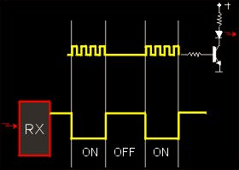
A square wave of approximately 27uS (microseconds) injected at the base of a transistor, can drive an infrared LED to transmit this pulsating light wave. Upon its presence, the commercial receiver will switch its output to high level (+5V).If you can turn on and off this frequency at the transmitter, your receiver's output will indicate when the transmitter is on or off.
Those IR demodulators have inverted logic at its output, when a burst of IR is sensed it drives its output to low level, meaning logic level = 1.
The TV, VCR, and Audio equipment manufacturers for long use infra-red at their remote controls. To avoid a Philips remote control to change channels in a Panasonic TV, they use different codification at the infrared, even that all of them use basically the same transmitted frequency, from 36 to 50 kHz. So, all of them use a different combination of bits or how to code the transmitted data to avoid interference.
RC-5
Various remote control systems are used in electronic equipment today. The RC5 control protocol is one of the most popular and is widely used to control numerous home appliances, entertainment systems and some industrial applications including utility consumption remote meter reading, contact-less apparatus control, telemetry data transmission, and car security systems. Philips originally invented this protocol and virtually all Philips’ remotes use this protocol. Following is a description of the RC5. When the user pushes a button on the hand-held remote, the device is activated and sends modulated infrared light to transmit the command. The remote separates command data into packets. Each data packet consists of a 14-bit data word, which is repeated if the user continues to push the remote button. The data packet structure is as follows:
- 2 start bits
- 1 control bit
- 5 address bits
- 6 command bits.
The start bits are always logic ‘1’ and intended to calibrate the optical receiver automatic gain control loop. Next, is the control bit. This bit is inverted each time the user releases the remote button and is intended to differentiate situations when the user continues to hold the same button or presses it again. The next 5 bits are the address bits and select the destination device. A number of devices can use RC5 at the same time. To exclude possible interference, each must use a different address. The 6 command bits describe the actual command. As a result, a RC5 transmitter can send the 2048 unique commands. The transmitter shifts the data word, applies Manchester encoding and passes the created one-bit sequence to a control carrier frequency signal amplitude modulator. The amplitude modulated carrier signal is sent to the optical transmitter, which radiates the infrared light. In RC5 systems the carrier frequency has been set to 36 kHz. Figure below displays the RC5 protocol.
The receiver performs the reverse function. The photo detector converts optical transmission into electric signals, filters it and executes amplitude demodulation. The receiver output bit stream can be used to decode the RC5 data word. This operation is done by the microprocessor typically, but complete hardware implementations are present on the market as well. Single-die optical receivers are being mass produced by a number of companies such as Siemens, Temic, Sharp, Xiamen Hualian, Japanese Electric and others. Please note that the receiver output is inverted (log. 1 corresponds to illumination absence).
IR RECEIVER
Description
The TSOP17... – Series are miniaturized receivers for infrared remote control systems. PIN diode and preamplifier are assembled on lead frame, the epoxy package is designed as IR filter.
The demodulated output signal can directly be decoded by a microprocessor. TSOP17...is the standard IR remote control receiver series, supporting all major transmission codes.
Features
_ Photo detector and preamplifier in one package
_ Internal filter for PCM frequency
_ Improved shielding against electrical field disturbance
_ TTL and CMOS compatibility
_ Output active low
_ Low power consumption
_ High immunity against ambient light
_ Continuous data transmission possible (up to 2400 bps)
_ Suitable burst length .10 cycles/burst
Fig 2.7 Block diagram of IR receiver

Suitable Data Format
The circuit of the TSOP17 is designed in that way that unexpected output pulses due to noise or disturbance signals are avoided. A band pass filter an integrator stage and an automatic gain control are used to suppress such disturbances. The distinguishing mark between data signal anddisturbance signal are carrier frequency, burst length and duty cycle. The data signal should fulfill the following condition: • Carrier frequency should be close to center frequency of the band pass (e.g. 38 kHz).
• Burst length should be 10 cycles/burst or longer.
• After each burst which is between 10 cycles and 70 cycles a gap time of at least 14 cycles is necessary.
• For each burst which is longer than 1.8ms a corresponding gap time is necessary at some time in the data stream. This gap time should have at least same length as the burst.
• Up to 1400 short bursts per second can be received continuously.
Some examples for suitable data format are: NEC Code, Toshiba Micom Format, Sharp Code, RC5 Code, RC6 Code, R–2000 Code, and SonyFormat (SIRCS). When a disturbance signal is applied to the TSOP17.It can still receive the data signal. However the sensitivity is reduced to that level that no unexpected pulses will occur. Some examples for such disturbance signals which are suppressed by the TSOP17 are:
• DC light (e.g. from tungsten bulb or sunlight)
• Continuous signal at 38 kHz or at any other frequency
• Signals from fluorescent lamps with electronic ballast (an example of the signal modulation is in the figure below).

2.4.3 Motion / Vibration Sensors

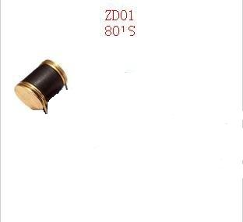
Fig 2.8 Vibration Sensor
Motion sensors are very similar in design to tilt switches; in fact, some tilt
Switches are used as motion sensors. The sensor will be in one condition (open or closed) at rest. When it is subjected to motion it will continually change state as long as it remains in motion. Some common applications include: anti-theft devices, man-down alarms to detect non motion, smart appliances to turn off power when not in use and portable equipment to do the same.

2.5Smoke Detector:
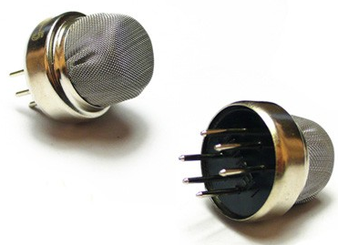
Fig 2.9 fire sensor

DESCRIPTION
MQ2 flammable gas and smoke sensor detects the concentrations of combustible gas in the air and outputs its reading as an analog voltage. The sensor can measure concentrations of flammable gas of 300 to 10,000 ppm. The sensor can operate at temperatures from -20 to 50°C and consumes less than 150 mA at 5 V.
Connecting five volts across the heating (H) pins keeps the sensor hot enough to function correctly. Connecting five volts at either the A or B pins causes the sensor to emit an analog voltage on the other pins. A resistive load between the output pins and ground sets the sensitivity of the detector. Please note that the picture in the datasheet for the top configuration is wrong. Both configurations have the same pin out consistent with the bottom configuration. The resistive load should be calibrated for your particular application using the equations in the datasheet, but a good starting value for the resistor is 20 kΩ.

FEATURES
- Wide detecting scope
- Fast response and High sensitivity
- Stable and long life
- Simple drive circuit
They are used in gas leakage detecting equipment’s in family and industry, are suitable for detecting of LPG, i-butane, propane, methane, alcohol, Hydrogen, smoke.
SENSITVITY ADJUSTMENT
Resistance value of MQ-2 is difference to various kinds and various concentration gases. So, when using these components, sensitivity adjustment is very necessary. We recommend that you calibrate the detector for 1000ppm liquefied petroleum gas<LPG>, or 1000ppm iso-butane<i-C4H10>concentration in air and use value of Load resistance that (RL) about 20 KΩ (5KΩ to 47 KΩ).
When accurately measuring, the proper alarm point for the gas detector should be determined after considering the temperature and humidity influence
2.6. DC Motor
2.6.1 Introduction:
DC motors are configured in many types and sizes, including brush less, servo, and gear motor types. A motor consists of a rotor and a permanent magnetic field stator. The magnetic field is maintained using either permanent magnets or electromagnetic windings. DC motors are most commonly used in variable speed and torque.
Motion and controls cover a wide range of components that in some way are used to generate and/or control motion. Areas within this category include bearings and bushings, clutches and brakes, controls and drives, drive components, encoders and resolves, Integrated motion control, limit switches, linear actuators, linear and rotary motion components, linear position sensing, motors (both AC and DC motors), orientation position sensing, pneumatics and pneumatic components, positioning stages, slides and guides, power transmission (mechanical), seals, slip rings, solenoids, springs.
Motors are the devices that provide the actual speed and torque in a drive system. This family includes AC motor types (single and multiphase motors, universal, servo motors, induction, synchronous, and gear motor) and DC motors (brush less, servo motor, and gear motor) as well as linear, stepper and air motors, and motor contactors and starters.
In any electric motor, operation is based on simple electromagnetism. A current-carrying conductor generates a magnetic field; when this is then placed in an external magnetic field, it will experience a force proportional to the current in the conductor, and to the strength of the external magnetic field. As you are well aware of from playing with magnets as a kid, opposite (North and South) polarities attract, while like polarities (North and North, South and South) repel. The internal configuration of a DC motor is designed to harness the magnetic interaction between a current-carrying conductor and an external magnetic field to generate rotational motion.

2.6.2 2-pole DC Electric Motor
Let's start by looking at a simple 2-pole DC electric motor (here red represents a magnet or winding with a "North" polarization, while green represents a magnet or winding with a "South" polarization).
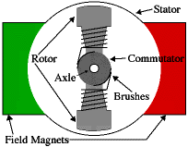
Fig 2.10Block Diagram of the DC motor
Every DC motor has six basic parts -- axle, rotor (a.k.a., armature), stator, commutator, field magnet(s), and brushes. In most common DC motors (and all that Beamers will see), the external magnetic field is produced by high-strength permanent magnets¹. The stator is the stationary part of the motor -- this includes the motor casing, as well as two or more permanent magnet pole pieces. The rotor (together with the axle and attached commutator) rotates with respect to the stator. The rotor consists of windings (generally on a core), the windings being electrically connected to the commutator. The above diagram shows a common motor layout -- with the rotor inside the stator (field) magnets.
The geometry of the brushes, commutator contacts, and rotor windings are such that when power is applied, the polarities of the energized winding and the stator magnet(s) are misaligned, and the rotor will rotate until it is almost aligned with the stator's field magnets. As the rotor reaches alignment, the brushes move to the next commutator contacts, and energize the next winding. Given our example two-pole motor, the rotation reverses the direction of current through the rotor winding, leading to a "flip" of the rotor's magnetic field, and driving it to continue rotating.
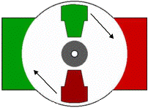
In real life, though, DC motors will always have more than two poles (three is a very common number). In particular, this avoids "dead spots" in the commutator. You can imagine how with our example two-pole motor, if the rotor is exactly at the middle of its rotation (perfectly aligned with the field magnets), it will get "stuck" there. Meanwhile,
Fig: 2.6.1Block Diagram of the DC motor having two poles only
With a two-pole motor, there is a moment where the commutator shorts out the power supply (i.e., both brushes touch both commutator contacts simultaneously). This would be bad for the power supply, waste energy, and damage motor components as well. Yet another disadvantage of such a simple motor is that it would exhibit a high amount of torque” ripple" (the amount of torque it could produce is cyclic with the position of the rotor).
So since most small DC motors are of a three-pole design, let's tinker with the workings of one via an interactive animation (JavaScript required):

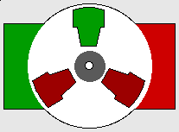
Fig2.11: Block Diagram of the DC motor having three poles
You'll notice a few things from this -- namely, one pole is fully energized at a time (but two others are "partially" energized). As each brush transitions from one commutator contact to the next, one coil's field will rapidly collapse, as the next coil's field will rapidly charge up (this occurs within a few microsecond). We'll see more about the effects of this later, but in the meantime you can see that this is a direct result of the coil windings' series wiring:
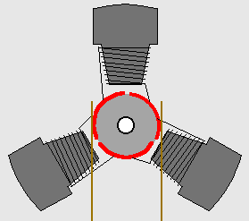
Fig2.12: Internal Block Diagram of the three pole DC motor

There's probably no better way to see how an average dc motor is put together, than by just opening one up. Unfortunately this is tedious work, as well as requiring the destruction of a perfectly good motor. This is a basic 3-pole dc motor, with 2 brushes and three commutator contacts.

2.6.3 Configuration of DC motors
H-Bridge: DC motors are typically controlled by using a transistor configuration called an "H-bridge". This consists of a minimum of four mechanical or solid-state switches, such as two NPN and two PNP transistors. One NPN and one PNP transistor are activated at a time. Both NPN and PNP transistors can be activated to cause a short across the motor terminals, which can be useful for slowing down the motor from the back EMF it creates.

Basic Theory
H-bridge. Sometimes called a "full bridge" the H-bridge is so named because it has four switching elements at the "corners" of the H and the motor forms the cross bar.
The key fact to note is that there are, in theory, four switching elements within the bridge. These four elements are often called, high side left, high side right, low side right, and low side left (when traversing in clockwise order).
The switches are turned on in pairs, either high left and lower right, or lower left and high right, but never both switches on the same "side" of the bridge. If both switches on one side of a bridge are turned on it creates a short circuit between the battery plus and battery minus terminals. If the bridge is sufficiently powerful it will absorb that load and your batteries will simply drain quickly. Usually however the switches in question melt.
To power the motor, you turn on two switches that are diagonally opposed. In the picture to the right, imagine that the high side left and low side right switches are turned on.
The current flows and the motor begins to turn in a "positive" direction. Turn on the high side right and low side left switches, then Current flows the other direction through the motor and the motor turns in the opposite direction.
Actually it is just that simple, the tricky part comes in when you decide what to use for switches. Anything that can carry a current will work, from four SPST switches, one DPDT switch, relays, transistors, to enhancement mode power MOSFETs.
One more topic in the basic theory section, quadrants. If each switch can be controlled independently then you can do some interesting things with the bridge, some folks call such a bridge a "four quadrant device" (4QD get it?). If you built it out of a single DPDT relay, you can really only control forward or reverse. You can build a small truth table that tells you for each of the switch's states, what the bridge will do. As each switch has one of two states, and there are four switches, there are 16 possible states. However, since any state that turns both switches on one side on is "bad" (smoke issues forth: P), there are in fact only four useful states (the four quadrants) where the transistors are turned on.
High Side Left | High Side Right | Low Side Left | Low Side Right | Quadrant Description
On | Off | Off | On | Forward Running
Off | On | On | Off | Backward Running
On | On | Off | Off | Braking
Off | Off | On | On | Braking
The last two rows describe a maneuver where you "short circuit" the motor which causes the motors generator effect to work against itself. The turning motor generates a voltage which tries to force the motor to turn the opposite direction. This causes the motor to rapidly stop spinning and is called "braking" on a lot of H-bridge designs.
Of course there is also the state where all the transistors are turned off. In this case the motor coasts freely if it was spinning and does nothing if it was doing nothing.

2.6.4. IMPLEMENTATION
1. Using Relays:
A simple implementation of an H Bridge using four SPST relays is shown. Terminal A is High Side Left, Terminal B is High Side Right, Terminal C is Low Side Left and Terminal D is Low Side Right. The logic followed is according to the table above.
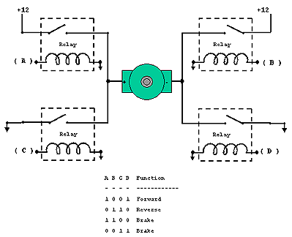
Warning: Never turn on A and C or B and D at the same time. This will lead to a short circuit of the battery and will lead to failure of the relays due to the large current.

2. Using Transistors:
We can better control our motor by using transistors or Field Effect Transistors (FETs). Most of what we have discussed about the relays H-Bridge is true of these circuits. See the diagram showing how they are connected. You should add diodes across the transistors to catch the back voltage that is generated by the motor's coil when the power is switched on and off. This fly back voltage can be many times higher than the supply voltage!
For information on building an H-Bridge using Transistors, have a look here.
Warning: If you don't use diodes, you could burn out your transistors. Also the same warning as in the diode case. Don't turn on A and C or B and D at the same time.
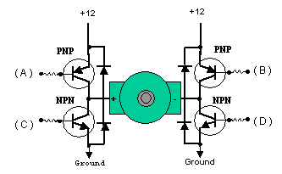
Transistors, being a semiconductor device, will have some resistance, which causes them to get hot when conducting much current. This is called not being able to sink or source very much power, i.e.: Not able to provide much current from ground or from plus voltage.
Mosfets are much more efficient, they can provide much more current and not get as hot. They usually have the fly back diodes built in so you don't need the diodes anymore. This helps guard against fly back voltage frying your ICs.
To use Mosfets in an H-Bridge, you need P-Channel Mosfets on top because they can "source" power, and N-Channel Mosfets on the bottom because then can "sink" power.
It is important that the four quadrants of the H-Bridge circuits be turned on and off properly. When there is a path between the positive and ground side of the H-Bridge, other than through the motor, a condition exists called "shoot through". This is basically a direct short of the power supply and can cause semiconductors to become ballistic, in circuits with large currents flowing. There are H-bridge chips available that are much easier, and safer, to use than designing your own H-Bridge circuit.
1. Using H-Bridge Devices
The L293 has 2 H-Bridges (actually 4 Half H-Bridges), can provide about 1 amp to each and occasional peak loads to 2 amps.
The L298 has 2 h-bridges on board, can handle 1amp and peak current draws to about 3amps. The LMD18200 has one h-bridge on board, can handle about 2 or 3 amps and can handle a peak of about 6 amps. There are several more commercially designed H-Bridge chips as well.
Once a Half H-bridge is enabled, it truth table is as follows:
INPUT  A | OUTPUT  Y
L | L
H | H
So you just give a High level when you want to turn the Half H-Bridge on and Low level when you want to turn it off. When the Half H-Bridge is on, the voltage at the output is equal to Vcc2.If you want to make a Full H-Bridge, you connect the motor (or the load) between the outputs of two Half H-Bridges and the inputs will be the two inputs of the Half H-Bridges.
Suppose we have connected Half H-Bridges 1 and 2 to form a Full H-Bridge. Now the truth table is as follows:
INPUT  1A | INPUT  2A | OUTPUT  1Y | OUTPUT  2Y | Description
L | L | L | L | Braking (both terminals ofmotor are Gnd)
L | H | L | H | Forward Running
H | L | H | L | Backward Running
H | H | H | H | Braking (both terminals of motor at Vcc2

L293D:
The L293 is an integrated circuit motor driver that can be used for simultaneous, bi-directional control of two small motors. Small means small. The L293 is limited to 600 mA, but in reality can only handle much small currents unless you have done some serious heat sinking to keep the case temperature down. Unsure about whether the L293 will work with your motor? Hook up the circuit and run your motor while keeping your finger on the chip. If it gets too hot to touch, you can't use it with your motor. (Note to ME2011 students: The L293 should be OK for your small motor but is not OK for your gear motor.)
The L293 comes in a standard 16-pin, dual-in line integrated circuit package. There is an L293 and an L293D part number. Pick the "D" version because it has built in fly back diodes to minimize inductive voltage spikes.
The pin out for the L293 in the 16-pin package is shown below in top view. Pin 1 is at the top left when the notch in the package faces up. Note that the names for pin functions may be slightly different than what is shown in the following diagrams.
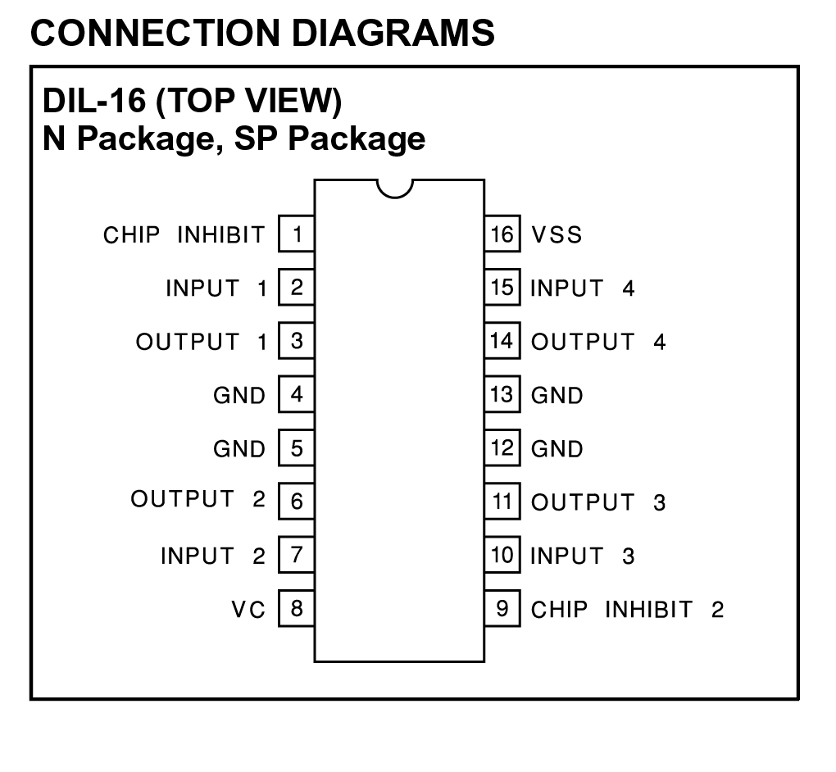
Fig2.13: Pin Diagram of L293D
The following schematic shows how to connect the L293 to your motor and the Stamp. Each motor takes 3 Stamp pins. If you are only using one motor, leave pins 9, 10, 11, 12, 13, 14, and 15 empty.
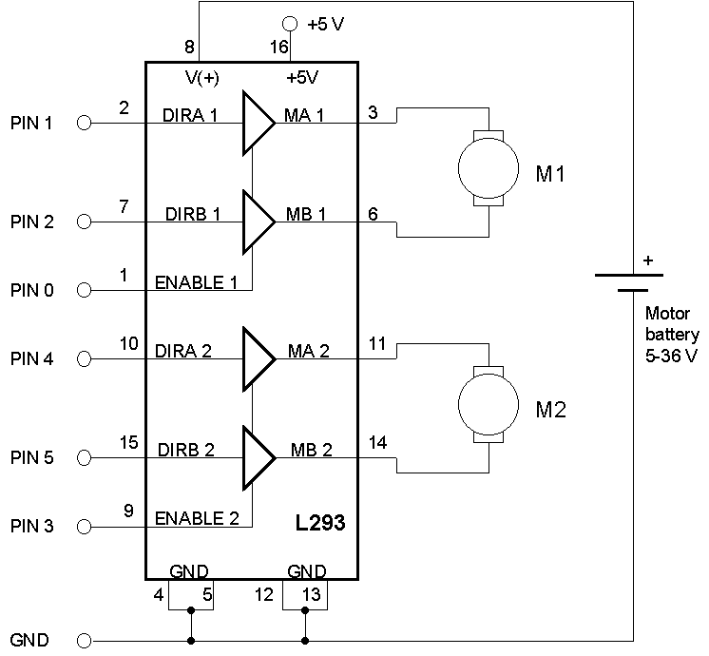
Assume you have only one motor connected with the enable tied to Stamp Pin 0, and the two direction controls tied to Stamp Pins 1 and 2.
Here is a table describing the control pin functions.
ENABLE | DIRA | DIRB | Function
H | H | L | Turn right
H | L | H | Turn left
H | L/H | L/H | Fast stop
L | Either | either | Slow stop
And here is a short sample program that exercises the L293.
Advantage:
You can control 2 motors in both directions instead of 4 in only one direction.
Disadvantages:
There is a 1.5V voltage drop within the L293D driver chip

CHAPTER -3
POWER SUPPLY

3.1 Introduction:
The power supplies are designed to convert high voltage AC mains electricity to a suitable low voltage supply for electronics circuits and other devices. A power supply can by broken down into a series of blocks, each of which performs a particular function. A d.c power supply which maintains the output voltage constant irrespective of a.c mains fluctuations or load variations is known as “Regulated D.C Power Supply”

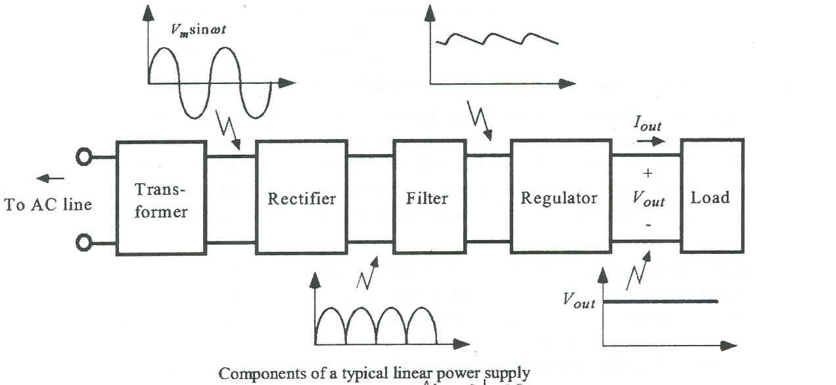
Fig: 3.1 Block Diagram of Power Supply

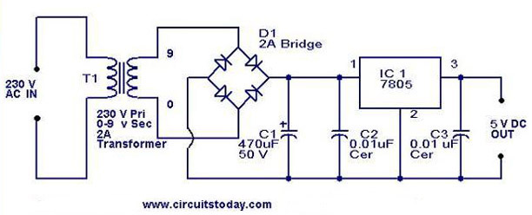
Fig: 3.2 Schematic Diagram of Power Supply
3.1.1 TRANSFORMER:
A transformer is an electrical device which is used to convert electrical power from one Electrical circuit to another without change in frequency.
When AC is applied to the primary winding of the power transformer it can either be stepped down or up depending on the value of DC needed. In our circuit the transformer of 230v/15-0-15v is used to perform the step down operation where a 230V AC appears as 15V AC across the secondary winding. One alteration of input causes the top of the transformer to be positive and the bottom negative.
The next alteration will temporarily cause the reverse. The current rating of the transformer used in our project is 2A. Apart from stepping down AC voltages, it gives isolation between the power source and power supply circuitries.

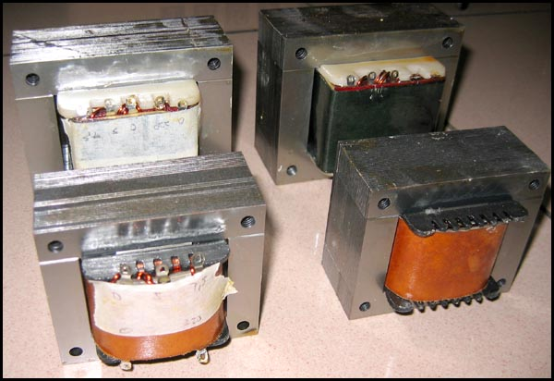
Fig: 3.3 Electrical Transformers

Turns ratio = Vp/ V_{S} = Np/N_{S}

Power Out= Power In

V_{S} X I_{S}=V_{P} X I_{P}
Vp = primary (input) voltage
Np = number of turns on primary coil
Ip = primary (input) current
3.2 RECTIFIER:
A circuit which is used to convert a.c to dc is known as RECTIFIER. The process of conversion a.c to d.c is called “rectification.
Comparison of rectifier circuits:
Parameter | Type of Rectifier
Parameter | Half wave Full wave Bridge
Number of diodes | 1 | 2 | 4
PIV of diodes | Vm | 2Vm | Vm
D.C output voltage | Vm/ | 2Vm/ | 2Vm/
Vdc,at  No-load | 0.318Vm | 0.636Vm | 0.636Vm
Ripple factor | 1.21 | 0.482 | 0.482
Ripple  Frequency | f | 2f | 2f
Rectification  Efficiency | 0.406 | 0.812 | 0.812
Transformer  Utilization  Factor(TUF) | 0.287 | 0.693 | 0.812
RMS voltage Vrms | Vm/2 | Vm/√2 | Vm/√2

Table: Comparisons of Rectifier Circuits

In the power supply unit, rectification is normally achieved using a solid state diode. Diode has the property that will let the electron flow easily in one direction at proper biasing condition. As AC is applied to the diode, electrons only flow when the anode and cathode is negative. Reversing the polarity of voltage will not permit electron flow.
A commonly used circuit for supplying large amounts of DC power is the bridge rectifier. A bridge rectifier of four diodes (4*IN4007) are used to achieve full wave rectification. Two diodes will conduct during the negative cycle and the other two will conduct during the positive half cycle. The DC voltage appearing across the output terminals of the bridge rectifier will be somewhat less than 90% of the applied rms value. Normally one alteration of the input voltage will reverse the polarities. Opposite ends of the transformer will therefore always be 180 degrees out of phase with each other.
For a positive cycle, two diodes are connected to the positive voltage at the top winding and only one diode conducts. At the same time one of the other two diodes conducts for the negative voltage that is applied from the bottom winding due to the forward bias for that diode. In this circuit due to positive half cycleD1 & D2 will conduct to give 10.8v pulsating DC. The DC output has a ripple frequency of 100Hz. Since each altercation produces a resulting output pulse, frequency = 2*50 Hz. The output obtained is not a pure DC and therefore filtration has to be done.

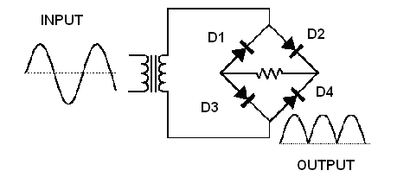
Fig: 3.4 Bridge Rectifier
OPERATION:
During positive half cycle of secondary, the diodes D2 and D3 are in forward biased while D1 and D4 are in reverse biased as shown in the fig(10). The current flow direction is shown in the fig (10) with dotted arrows.
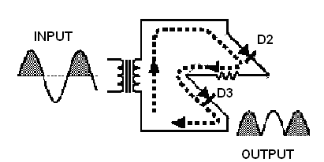
Fig: 3.5 Operation during Positive Cycle

During negative half cycle of secondary voltage, the diodes D1 and D4 are in forward biased while D2 and D3 are in reverse biased as shown in the fig(11). The current flow direction is shown in the fig (11) with dotted arrows.
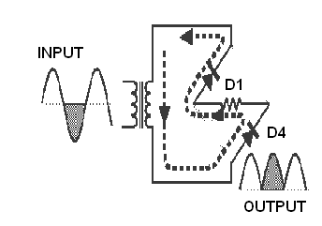
Fig: 3.6 Operations during Negative Cycle
3.3 FILTER:
A Filter is a device which removes the a.c component of rectifier output but allows the d.c component to reach the load.
Capacitor Filter:
We have seen that the ripple content in the rectified output of half wave rectifier is 121% or that of full-wave or bridge rectifier or bridge rectifier is 48% such high percentages of ripples is not acceptable for most of the applications. Ripples can be removed by one of the following methods of filtering.
(a) A capacitor, in parallel to the load, provides an easier by –pass for the ripples voltage though it due to low impedance. At ripple frequency and leave the d.c.to appears the load.
(b) An inductor, in series with the load, prevents the passage of the ripple current (due to high impedance at ripple frequency) while allowing the d.c (due to low resistance to d.c)
(c) Various combinations of capacitor and inductor, such as L-section filter section filter, multiple section filter etc.
3.4 CAPACITORS:
A capacitor or condenser is a passive electronic component consisting of a pair of conductors separated by a dielectric. When a voltage potential difference exists between the conductors, an electric field is present in the dielectric. This field stores energy and produces a mechanical force between the plates. The effect is greatest between wide, flat, parallel, narrowly separated conductors.
An ideal capacitor is characterized by a single constant value, capacitance, which is measured in farads. This is the ratio of the electric charge on each conductor to the potential difference between them. In practice, the dielectric between the plates passes a small amount of leakage current. The conductors and leads introduce an equivalent series resistance and the dielectric has an electric field strength limit resulting in a breakdown voltage.

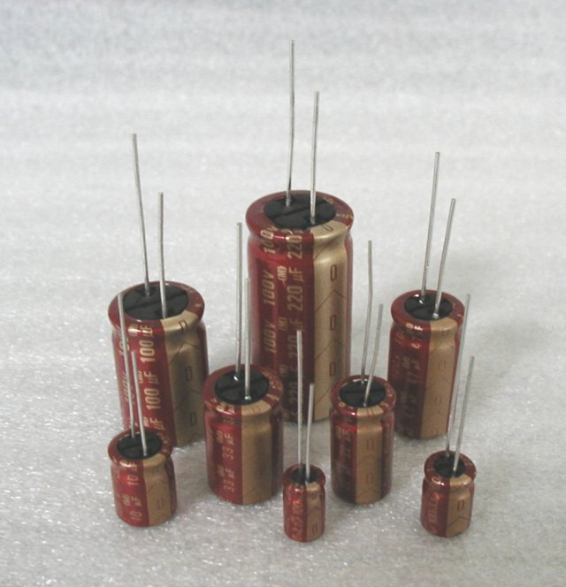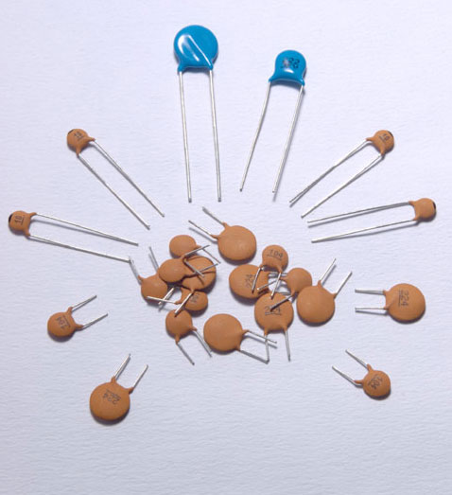
An ideal capacitor is characterized by a single constant value, capacitance, which is measured in farads. This is the ratio of the electric charge on each conductor to the potential difference between them. In practice, the dielectric between the plates passes a small amount of leakage current. The conductors and leads introduce an equivalent series resistance and the dielectric has an electric field strength limit resulting in a breakdown voltage.
The properties of capacitors in a circuit may determine the resonant frequency and quality factor of a resonant circuit, power dissipation and operating frequency in a digital logic circuit, energy capacity in a high-power system, and many other important aspects.
A capacitor (formerly known as condenser) is a device for storing electric charge. The forms of practical capacitors vary widely, but all contain at least two conductors separated by a non-conductor. Capacitors used as parts of electrical systems, for example, consist of metal foils separated by a layer of insulating film.
Capacitors are widely used in electronic circuits for blocking direct current while allowing alternating current to pass, in filter networks, for smoothing the output of power supplies, in the resonant circuits that tune radios to particular frequencies and for many other purposes.
A capacitor is a passive electronic consisting of a pair of conductors separated by a dielectric (insulator). When there is a potential difference (voltage) across the conductors, a static electric field develops in the dielectric that stores energy and produces a mechanical force between the conductors. An ideal capacitor is characterized by a single constant value, capacitance, measured in farads. This is the ratio of the electric charge on each conductor to the potential difference between them.
The capacitance is greatest when there is a narrow separation between large areas of conductor, hence capacitor conductors are often called "plates", referring to an early means of construction. In practice the dielectric between the plates passes a small amount of leakage current and also has an electric field strength limit, resulting in a breakdown voltage, while the conductors and leads introduce an undesired inductance and resistance.

Theory of operation:
Main article: Capacitance
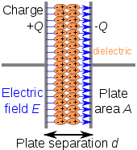
Charge separation in a parallel-plate capacitor causes an internal electric field. A dielectric (orange) reduces the field and increases the capacitance.
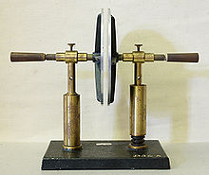

A capacitor consists of two conductors separated by a non-conductive region the non-conductive region is called the dielectric or sometimes the dielectric medium. In simpler terms, the dielectric is just an electrical insulator. Examples of dielectric mediums are glass, air, paper, vacuum, and even a semiconductor depletion chemically identical to the conductors. A capacitor is assumed to be self-contained and isolated, with no net electric charge and no influence from any external electric field.
The conductors thus hold equal and opposite charges on their facing surfaces, and the dielectric develops an electric field. In SI units, a capacitance of one farad means that one coulomb of charge on each conductor causes a voltage of one volt across the device. The capacitor is a reasonably general model for electric fields within electric circuits. An ideal capacitor is wholly characterized by a constant capacitance c, defined as the ratio of charge ±q on each conductor to the voltage v between them:
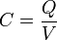
Sometimes charge build-up affects the capacitor mechanically, causing its capacitance to vary. In this case, capacitance is defined in terms of incremental changes:
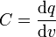
3.5 RESISTORS
A resistor is a two-terminal electronic component designed to oppose an electric current by producing a voltage drop between its terminals in proportion to the current, that is, in accordance with Ohm's law:
V = IR
Resistors are used as part of electrical networks and electronic circuits. They are extremely commonplace in most electronic equipment. Practical resistors can be made of various compounds and films, as well as resistance wire (wire made of a high-resistivity alloy, such as nickel/chrome).
Resistors are common elements of electrical networks and electronic circuits and are ubiquitous in most electronic equipment. Practical resistors can be made of various compounds and films, as well as resistance wire (wire made of a high-resistivity alloy, such as nickel-chrome). Resistors are also implemented within integrated circuits, particularly analog devices, and can also beintegratedintohybridandprintedcircuits.
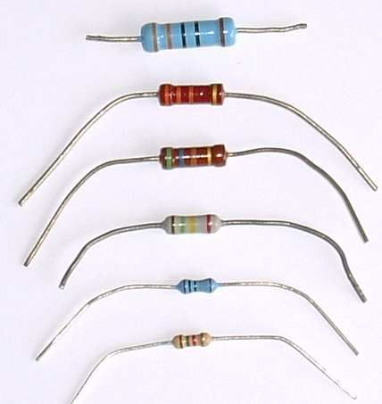
Fig 3.7 Resistors
The primary characteristics of resistors are their resistance and the power they can dissipate. Other characteristics include temperature coefficient, noise, and inductance. Less well-known is critical resistance, the value below which power dissipation limits the maximum permitted current flow, and above which the limit is applied voltage. Critical resistance depends upon the materials constituting the resistor as well as its physical dimensions; it's determined by design.
Resistors can be integrated into hybrid and printed circuits, as well as integrated circuits. Size, and position of leads (or terminals) are relevant to equipment designers; resistors must be physically large enough not to overheat when dissipating their power.
A resistor is a two-terminalpassiveelectronic component which implements electrical resistance as a circuit element. When a voltage V is applied across the terminals of a resistor, a current I will flow through the resistor in direct proportion to that voltage. The reciprocal of the constant of proportionality is known as the resistance R, since, with a given voltage V, a larger value of R further "resists" the flow of current I as given by Ohm's law:
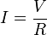
Resistors are common elements of electrical networks and electronic circuits and are ubiquitous in most electronic equipment. Practical resistors can be made of various compounds and films, as well as resistance wire (wire made of a high-resistivity alloy, such as nickel-chrome). Resistors are also implemented within integrated circuits, particularly analog devices, and can also be integrated into hybrid and printed circuits.
The electrical functionality of a resistor is specified by its resistance: common commercial resistors are manufactured over a range of more than 9 orders of magnitude. When specifying that resistance in an electronic design, the required precision of the resistance may require attention to the manufacturing tolerance of the chosen resistor, according to its specific application. The temperature coefficient of the resistance may also be of concern in some precision applications. Practical resistors are also specified as having a maximum power rating which must exceed the anticipated power dissipation of that resistor in a particular circuit: this is mainly of concern in power electronics applications. Resistors with higher power ratings are physically larger and may require heat sinking. In a high voltage circuit, attention must sometimes be paid to the rated maximum working voltage of the resistor.
The series inductance of a practical resistor causes its behavior to depart from ohms law; this specification can be important in some high-frequency applications for smaller values of resistance. In a low-noise amplifier or pre-amp the noise characteristics of a resistor may be an issue. The unwanted inductance, excess noise, and temperature coefficient are mainly dependent on the technology used in manufacturing the resistor. They are not normally specified individually for a particular family of resistors manufactured using a particular technology.
A family of discrete resistors is also characterized according to its form factor, that is, the size of the device and position of its leads (or terminals) which is relevant in the practical manufacturing of circuits using them.

Units
The ohm (symbol: Ω) is the SI unit of electrical resistance, named after Georg Simon Ohm. An ohm is equivalent to a volt per ampere. Since resistors are specified and manufactured over a very large range of values, the derived units of milliohm (1 mΩ = 10⁻³ Ω), kilo ohms (1 kΩ = 10³ Ω), and mega ohm (1 MΩ = 10⁶ Ω) are also in common usage.
The reciprocal of resistance R is called conductance G = 1/R and is measured in Siemens (SI unit), sometimes referred to as a mho. Thus a Siemens is the reciprocal of an ohm: S = Ω ⁻ ¹. Although the concept of conductance is often used in circuit analysis, practical resistors are always specified in terms of their resistance (ohms) rather than conductance.

Theory of operation

Ohm's law
The behavior of an ideal resistor is dictated by the relationship specified in Ohm's law:
Ohm's law states that the voltage (V) across a resistor is proportional to the current (I) passing through it, where the constant of proportionality is the resistance (R).
Equivalently, Ohm's law can be stated:
This formulation of Ohm's law states that, when a voltage (V) is present across a resistance (R), a current (I) will flow through the resistance. This is directly used in practical computations. For example, if a 300 ohm resistor is attached across the terminals of a 12 volt battery, then a current of 12 / 300 = 0.04 amperes (or 40 mill amperes) will flow through that resistor

3.6 Liquid crystal display:

Liquid crystal displays (LCDs) have materials, which combine the properties of both liquids and crystals. Rather than having a melting point, they have a temperature range within which the molecules are almost as mobile as they would be in a liquid, but are grouped together in an ordered form similar to a crystal.
An LCD consists of two glass panels, with the liquid crystal material sand witched in between them. The inner surface of the glass plates are connected with transparent electrodes which define the character, symbols or patterns to be displayed polymeric layers are present in between the electrodes and the liquid crystal, which makes the liquid crystal molecules to maintain a defined orientation angle.
One each polarisers are pasted outside the two glass panels. These polarisers would rotate the light rays passing through them to a definite angle, in a particular direction.
When the LCD is in the off state, light rays are rotated by the two polariser and the liquid crystal, such that the light rays come out of the LCD without any orientation, and hence the LCD appears transparent.
When sufficient voltage is applied to the electrodes, the liquid crystal molecules would be aligned in a specific direction. The light rays passing through the LCD would be rotated by the polarisers, which would result in activating/ highlighting the desired characters.
The LCD’s are lightweight with only a few millimeters thickness. Since the LCD’s consume less power, they are compatible with low power electronic circuits, and can be powered for long durations.
The LCD’s don’t generate light and so light is needed to read the display. By using backlighting, reading is possible in the dark. The LCD’s have long life and a wide operating temperature range.
Changing the display size or the layout size is relatively simple which makes the LCD’s more customers friendly.
The LCDs used exclusively in watches, calculators and measuring instruments are the simple seven-segment displays, having a limited amount of numeric data. The recent advances in technology have resulted in better legibility, more information displaying capability and a wider temperature range. These have resulted in the LCDs being extensively used in telecommunications and entertainment electronics. The LCDs have even started replacing the cathode ray tubes (CRTs) used for the display of text and graphics, and also in small TV applications.
This section describes the operation modes of LCD’s then describe how to program and interface an LCD to 8051 using Assembly and C.

LCD operation
In recent years the LCD is finding widespread use replacing LEDs (seven-segment LEDs or other multisegment LEDs).This is due to the following reasons:
1. The declining prices of LCDs.
2. The ability to display numbers, characters and graphics. This is contract to LEDs, which are limited to numbers and a few characters.
3. Ease of programming for characters and graphics.
LCD pin description
The LCD discussed in this section has 14 pins. The function of each pins is given in table.

TABLE 3.1: Pin description for LCD:
Pin | Symbol | I/O | Description
1 | Vss | -- | Ground
2 | Vcc | -- | +5V power supply
3 | VEE | -- | Power supply to control contrast
4 | RS | I | RS=0 to select command register  RS=1 to select  data register
5 | R/W | I | R/W=0 for write  R/W=1 for read
6 | E | I/O | Enable
7 | DB0 | I/O | The 8-bit data bus
8 | DB1 | I/O | The 8-bit data bus
9 | DB2 | I/O | The 8-bit data bus
10 | DB3 | I/O | The 8-bit data bus
11 | DB4 | I/O | The 8-bit data bus
12 | DB5 | I/O | The 8-bit data bus
13 | DB6 | I/O | The 8-bit data bus
14 | DB7 | I/O | The 8-bit data bus

Uses:
The LCDs used exclusively in watches, calculators and measuring instruments are the simple seven-segment displays, having a limited amount of numeric data. The recent advances in technology have resulted in better legibility, more information displaying capability and a wider temperature range. These have resulted in the LCDs being extensively used in telecommunications and entertainment electronics. The LCDs have even started replacing the cathode ray tubes (CRTs) used for the display of text and graphics, and also in small TV applications.

3.6.1. LCD Interfacing:

To send any command from table 2 to the LCD, make pin RS=0.for data, make RS=1.Then send a high –to-low pulse to the E pin to enable the internal latch of the LCD.
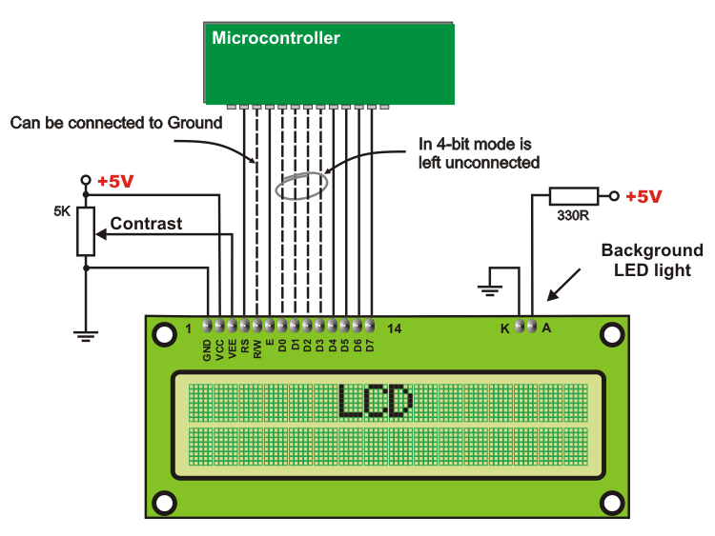
Sending commands and data to LCDs with a time delay:

Fig 3.8LCD Interfacing

3.7 LED:
Here the IR transmitter is nothing but the IR LED. It just looks like a normal LED but transmits the IR signals. Since the IR rays are out of the visible range we cannot observe the rays from the transmitter. These are infrared LEDs; the light output is not visible by our eyes. They can be used as replacement LEDs for remote controls, night vision for camcorders, invisible beam sensors, etc.
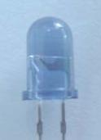
Fig: 3.9 IR LED
Advantages:
  - Infrared LEDs are ideal light sources for use with night vision goggles, surveillance cameras, and medical imaging, recognition and calibration systems.
  - Due to their resistance to ambient-light impediments and electromagnetic interference (EMI), Infrared LEDs enhance the performance of wireless computer-to-PDA links, collision avoidance systems, automation equipment, biomedical instrumentation, and telecommunications equipment.
  - Solid-state design renders Infrared LEDs impervious to electrical and mechanical shock, vibration, frequent switching and environmental extremes. With an average life span of 100,000-plus hours (11 years), Infrared LEDs operate reliably year-

CHAPTER -4
GSM-TECHNOLOGY
4.1 Introduction
Definition:
Global System for Mobile (GSM) is a second generation cellular standard developed to cater voice services and data delivery using digital modulation.
GSM-History
• Developed by Group Special Mobile (founded 1982) which was an initiative of CEPT (Conference
European Post and Telecommunication)
• Aim: to replace the incompatible analog system
• Presently the responsibility of GSM standardization resides with special mobilegroup under ETSI (European telecommunication Standards Institute) Full set of specifications phase-I became available in 1990
• Under ETSI, GSM is named as “Global System for Mobile communication “
• Today many providers all over the world use GSM (more than 135Countries in Asia, Africa, Europe, Australia, America)
•More than 1300 million subscribers in world and 45 million subscribers in India.

GSM IN WORLD

GSM IN INDIA

4.2 GSM SERVICES
- Tele-services
- Bearer or Data Services
4.2.1 Tele-services
• Telecommunication services that enable voice communication
Via mobile phones
• Offered services
- Mobile telephony
- Emergency calling
4.2.2 Bearer or Data Services
- Include various data services for information transfer between GSM and other networks like PSTN, ISDN etc. at rates from 300 to 9600 bps
- Short Message Service (SMS)
- up to 160 character alphanumeric data transmission to/from the mobile terminal
- Unified Messaging Services(UMS)
- Group 3 fax
- Voice mailbox
- Electronic mail
4.2.3Supplementary services
Call related services:
- Call Waiting- Notification of an incoming call while on the handset
- Call Hold- Put a caller on hold to take another call
- Call Barring- All calls, outgoing calls, or incoming calls
- Call Forwarding- Calls can be sent to various numbers defined by the user
- Multi Party Call Conferencing - Link multiple calls together
- CLIP – Caller line identification presentation
- CLIR – Caller line identification restriction
- CUG – Closed user group
4.3GSM System Architecture-I
Mobile Station (MS)
Mobile Equipment (ME)
Subscriber Identity Module (SIM)
Base Station Subsystem (BSS)
Base Transceiver Station (BTS)
Base Station Controller (BSC)
Network Switching Subsystem (NSS)
Mobile Switching Center (MSC)
Home Location Register (HLR)
Visitor Location Register (VLR)
Authentication Center (AUC)
Equipment Identity Register (EIR)
System Architecture Mobile Station (MS)
The Mobile Station is made up of two entities:
1. Mobile Equipment (ME)
2. Subscriber Identity Module (SIM)
Mobile Equipment
- Portable, vehicle mounted, hand held device
- Uniquely identified by an IMEI (International Mobile Equipment Identity)
- Voice and data transmission
- Monitoring power and signal quality of surrounding cells for optimum handover
- Power level : 0.8W – 20 W
- 160 character long SMS.

Subscriber Identity Module (SIM)
- Smart card contains the International Mobile Subscriber Identity (IMSI)
- Allows user to send and receive calls and receive other subscribed services
- Encoded network identification details
  - Key Ki,Kc and A3,A5 and A8 algorithms
- Protected by a password or PIN
- Can be moved from phone to phone – contains key information to activate the phone
System Architecture Base Station Subsystem (BSS)
Base Station Subsystem is composed of two parts that communicate across the standardized AbisInterface allowing operation between components made by different suppliers
- Base Transceiver Station (BTS)
- Base Station Controller (BSC)
System Architecture Base Station Subsystem (BSS)
- Consists of Transceivers (TRX) units Base Transceiver Station (BTS):
- Encodes, encrypts, multiplexes, modulates and feeds the RF signals to the antenna.
- Frequency hopping
- Communicates with Mobile station and BSC

Base Station Controller (BSC)
- Manages Radio resources for BTS
- Assigns Frequency and time slots for all MS’s in its area
- Handles call set up
- Transcoding and rate adaptation functionality
- Handover for each MS
- Radio Power control
- It communicates with MSC and BTS

System Architecture Network Switching Subsystem (NSS)
Mobile Switching Center (MSC)
- Heart of the network
- Manages communication between GSM and other networks
- Call setup function and basic switching
- Call routing
- Billing information and collection
- Mobility management
- Registration
- Location Updating
- Inter BSS and inter MSC call handoff
MSC does gateway function while its customer roams to other network by using HLR/VLR.

System Architecture Network Switching Subsystem
- Home Location Registers (HLR)
- Permanent database about mobile subscribers in a large service area (generally one per GSM network operator)
- Database contains IMSI, MS ISDN, prepaid/postpaid, roaming restrictions, and supplementary services.
- Visitor Location Registers (VLR)
- Temporary database which updates whenever new MS enters its area, by HLR database
- Controls those mobiles roaming in its area
- Reduces number of queries to HLR
- Database contains IMSI, TMSI, MSISDN, MSRN, Location Area, authentication key

- Authentication Center (AUC)
- Protects against intruders in air interface
- Maintains authentication keys and algorithms and provides security triplets ( RAND, SRES, Kc)
- Generally associated with HLR

- Equipment Identity Register (EIR)
- - Database that is used to track handsets using the IMEI (International Mobile Equipment Identity)
- Made up of three sub-classes: The White List, The Black List and the Gray List
- Only one EIR per PLMN
  - GSM Specifications-1

- RF Spectrum
GSM 900
- Mobile to BTS (uplink): 890-915 MHz
- BTS to Mobile(downlink):935-960 MHz
Bandwidth: 2* 25 MHz
GSM 1800
Mobile to BTS (uplink): 1710-1785 MHz
BTS to Mobile (downlink) 1805-1880 MHz
Bandwidth: 2* 75 MHz
4.4.1 GSM Specification-II
- Carrier Separation : 200 KHz
- Duplex Distance : 45 MHz
- No. of RF carriers : 124
- Access Method : TDMA/FDMA
- Modulation Method : GMSK
- Modulation data rate : 270.833 Kbp

- 4.5 OPERATION OF GSM

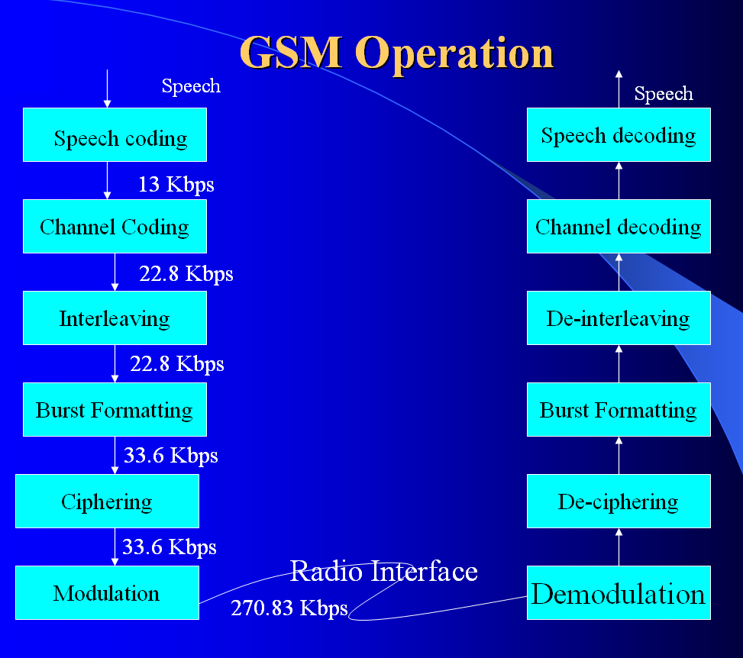
Call Routing
- Call Originating from MS
- Call termination to MS

Outgoing Call
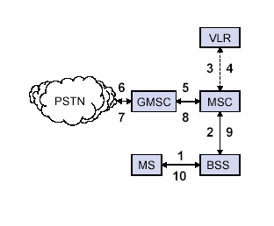
- MS sends dialed number to BSS
- BSS sends dialed number to MSC
- MSC checks VLR if MS is allowed the requested service.
- If so, MSC asks BSS to allocate resources for call.
- MSC routes the call to GMSC
- GMSC routes the call to local exchange of called user
- Answer back (ring back) tone is routed from called user to MS via
  - GMSC, MSC, BSS

Incoming Call:
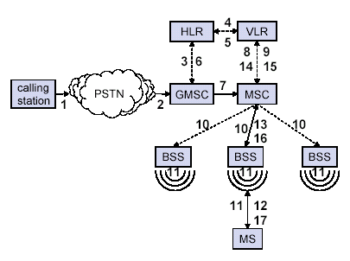
- Calling a GSM subscribers
- Forwarding call to GSMC
- Signal Setup to HLR
- Request MSRN from VLR
- Forward responsible MSC to GMSC
- Forward Call to current MSC
- Get current status of MS
- Paging of MS
- MS answers
- Security checks
- Set up connection
Handovers
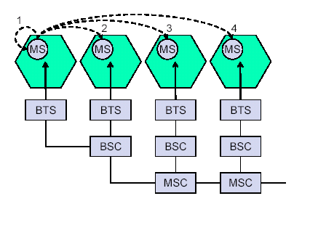
- Between 1 and 2 – Inter BTS / Intra BSC
- Between 1 and 3 –
  - Inter BSC/ Intra MSC
- Between 1 and 4 –
  - Inter MSC
Security in GSM
- On air interface, GSM uses encryption and TMSI instead of IMSI.
- SIM is provided 4-8 digit PIN to validate the ownership of SIM
- 3 algorithms are specified :
- A3 algorithm for authentication
- A5 algorithm for encryption
- A8 algorithm for key generation
Characteristics of GSM Standard
- Fully digital system using 900, 1800 MHz frequency band.
- TDMA over radio carriers (200 KHz carrier spacing.
- 8 full rate or 16 half rate TDMA channels per carrier.
- User/terminal authentication for fraud control.
- Encryption of speech and data transmission over the radio path.
- Full international roaming capability.
- Low speed data services (up to 9.6 Kb/s).
- Compatibility with ISDN.
- Support of Short Message Service (SMS).
Advantages of GSM over Analog system:
- Capacity increases
- Reduced RF transmission power and longer battery life.
- International roaming capability.
- Better security against fraud (through terminal validation and user authentication).
- Encryption capability for information security and privacy.
- Compatibility with ISDN,leading to wider range of services

4.6 GSM Application:
- Mobile telephony
- GSM-R
- Telemetry System
- Fleet management
- Automatic meter reading
- Toll Collection
- Remote control and fault reporting of DG sets
- Value Added Services
  - Future of GSM
- 2nd Generation
- GSM -9.6 Kbps (data rate)
- 2.5 Generation ( Future of GSM)
- HSCSD (High Speed ckt Switched data)
- Data rate : 76.8 Kbps (9.6 x 8 kbps)
- GPRS (General Packet Radio service)
- Data rate: 14.4 - 115.2 Kbps
- EDGE (Enhanced data rate for GSM Evolution)
- Data rate: 547.2 Kbps (max)
- 3 Generation
- WCDMA(Wide band CDMA)
- Data rate : 0.348 – 2.0 Mbps

CHAPTER 5
GPS TECHNOLOGY
5.1 Introduction:
GPS:Global Positioning System (GPS) technology is changing the way we work and play. You can use GPS technology when you are driving, flying, fishing, sailing, hiking, running, biking, working, or exploring. With a GPS receiver, you have an amazing amount of information at your fingertips. Here are just a few examples of how you can use GPS technology.
Know precisely how far you have run and at what pace while tracking your path so you can find your way home. Pinpoint the perfect fishing spot on the water and easily relocate it.Get the closest location of your favorite restaurant when you are out-of-town. Find the nearest airport or identify the type of airspace in which you are flying
The Global Positioning System (GPS) is a satellite-based navigation system that sends and receives radio signals. A GPS receiver acquires these signals and provides you with information. Using GPS technology, you can determine location, velocity, and time, 24 hours a day, in any weather conditions anywhere in the world—for free.
GPS, formally known as the NAVSTAR (Navigation Satellite Timing and Ranging). Global Positioning System originally was developed for the military. Because of its popular navigation capabilities and because you can access GPS technology using small, inexpensive equipment, the government made the system available for civilian use. The USA owns GPS technology and the Department of Defense maintains it.
GPS technology requires the following three segments.
- Space segment.
- Control segment.
- User segment

Basic Components of GPS
A GPS receiver calculates its position by precisely timing the signals sent by GPS satellites high above the Earth. Each satellite continually transmits messages that include the time the message was transmitted
    - satellite position at time of message transmission
The receiver uses the messages it receives to determine the transit time of each message and computes the distance to each satellite using the speed of light. These distances along with the satellites' locations are used with the possible aid of trilateration, depending on which algorithm is used, to compute the position of the receiver. This position is then displayed, perhaps with a moving map display or latitude and longitude; elevation information may be included. Many GPS units show derived information such as direction and speed, calculated from position changes.
In typical GPS operation, four or more satellites must be visible to obtain an accurate result. Three satellites might seem enough to solve for position since in typical GPS operation the surfaces of three spheres intersect in only two points and only one of these two points is near earth. However, a three satellite solution requires an extremely precise clock. Clocks accurate enough (typically atomic clocks) are very expensive, large, power hungry. To avoid the need to use these very expensive clocks, receivers use much less expensive clocks and use the Bancroft or other algorithm discussed in the section,” Navigation equations", to compute the three components of receiver position and the time correction required from the data provided by four satellites. The very accurately computed time is sometimes hidden by GPS receivers, which use only the location. A few specialized GPS applications do however use the time; these include time transfer, traffic signal timing, and synchronization of cell phone base stations.
Although four satellites are required for normal operation, fewer apply in special cases. If one variable is already known, a receiver can determine its position using only three satellites. For example, a ship or aircraft may have known elevation. Some GPS receivers may use additional clues or assumptions such as reusing the last known altitude, dead reckoning, inertial navigation, or including information from the vehicle computer, to give a (possibly degraded) position when fewer than four satellites are visible.

Structure
The current GPS consists of three major segments. These are the space segment (SS), a control segment (CS), and a user segment (US).^{[41]} The U.S. Air Force develops, maintains, and operates the space and control segments. GPS satellites broadcast signals from space, and each GPS receiver uses these signals to calculate its three-dimensional location (latitude, longitude, and altitude) and the current time.^{[42]}
The space segment is composed of 24 to 32 satellites in medium Earth orbit and also includes the payload adapters to the boosters required to launch them into orbit. The control segment is composed of a master control station, an alternate master control station, and a host of dedicated and shared ground antennas and monitor stations. The user segment is composed of hundreds of thousands of U.S. and allied military users of the secure GPS Precise Positioning Service, and tens of millions of civil, commercial, and scientific users of the Standard Positioning Service (GPS navigation devices).

5.2 Space segment

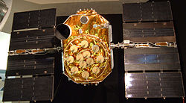
Fig 5.1 Space Segment
The space segment (SS) is composed of the orbiting GPS satellites or Space Vehicles (SV) in GPS parlance. The GPS design originally called for 24 SVs, eight each in three approximately circular orbits,^{[43]} but this was modified to six orbital planes with four satellites each.^{[44]} The orbits are centered on the Earth, not rotating with the Earth, but instead fixed with respect to the distant stars. The six orbit planes have approximately 55° inclination (tilt relative to Earth's equator) and are separated by 60° right ascension of the ascending node (angle along the equator from a reference point to the orbit's intersection). The orbital period is one-half a sidereal day, i.e. 11 hours and 58 minutes. The orbits are arranged so that at least six satellites are always within line of sight from almost everywhere on Earth's surface. The result of this objective is that the four satellites are not evenly spaced (90 degrees) apart within each orbit. In general terms, the angular difference between satellites in each orbit is 30, 105, 120, and 105 degrees apart which, of course, sum to 360 degrees.
Orbiting at an altitude of approximately 20,200 km (12,600 mi); orbital radius of approximately 26,600 km (16,500 mi), each SV makes two complete orbits each sidereal day, repeating the same ground track each day.^{[49]} This was very helpful during development because even with only four satellites, correct alignment means all four are visible from one spot for a few hours each day. For military operations, the ground track repeat can be used to ensure good coverage in combat zones.
As of March 2008, there are 31 actively broadcasting satellites in the GPS constellation, and two older, retired from active service satellites kept in the constellation as orbital spares. The additional satellites improve the precision of GPS receiver calculations by providing redundant measurements. With the increased number of satellites, the constellation was changed to a no uniform arrangement. Such an arrangement was shown to improve reliability and availability of the system, relative to a uniform system, when multiple satellites fail.^{[51]} About nine satellites are visible from any point on the ground at any one time (see animation at right), ensuring considerable redundancy over the minimum four satellites needed for a position.

5.3 Control segment
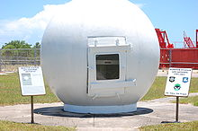
Fig 5.2 control segment
The control segment is composed of
- a master control station (MCS),
- an alternate master control station,
- four dedicated ground antennas and
- six dedicated monitor stations
The MCS can also access U.S. Air Force Satellite Control Network (AFSCN) ground antennas (for additional command and control capability) and NGA (National Geospatial-Intelligence Agency) monitor stations. The flight paths of the satellites are tracked by dedicated U.S. Air Force monitoring stations in Hawaii, Kwajalein, Ascension Island, Diego Garcia, Colorado Springs, Colorado and Cape Canaveral, along with shared NGA monitor stations operated in England, Argentina, Ecuador, Bahrain, Australia and Washington DC.^{[52]} The tracking information is sent to the Air Force Space Command MCS at Schriever Air Force Base 25 km (16 mi) ESE of Colorado Springs, which is operated by the 2nd Space Operations Squadron (2 SOPS) of the U.S. Air Force. Then 2 SOPS contacts each GPS satellite regularly with a navigational update using dedicated or shared (AFSCN) ground antennas (GPS dedicated ground antennas are located at Kwajalein, Ascension Island, Diego Garcia, and Cape Canaveral). These updates synchronize the atomic clocks on board the satellites to within a few nanoseconds of each other, and adjust the ephemeris of each satellite's internal orbital model. The updates are created by a Kalman filter that uses inputs from the ground monitoring stations, space weather information, and various other inputs.
Satellite maneuvers are not precise by GPS standards. So to change the orbit of a satellite, the satellite must be marked unhealthy, so receivers will not use it in their calculation. Then the maneuver can be carried out, and the resulting orbit tracked from the ground. Then the new ephemeris is uploaded and the satellite marked healthy again.
The Operation Control Segment (OCS) currently serves as the control segment of record. It provides the operational capability that supports global GPS users and keeps the GPS system operational and performing within specification.
OCS successfully replaced the legacy 1970’s-era mainframe computer at Schriever Air Force Base in September 2007. After installation, the system helped enable upgrades and provide a foundation for a new security architecture that supported the U.S. armed forces. OCS will continue to be the ground control system of record until the new segment, Next Generation GPS Operation Control System ^{[2]} (OCX), is fully developed and functional.
The new capabilities provided by OCX will be the cornerstone for revolutionizing GPS’s mission capabilities, and enabling ^{[54]} Air Force Space Command to greatly enhance GPS operational services to U.S. combat forces, civil partners and myriad of domestic and international users.
The GPS OCX program also will reduce cost, schedule and technical risk. It is designed to provide 50% ^{[55]} sustainment cost savings through efficient software architecture and Performance-Based Logistics. In addition, GPS OCX expected to cost millions less than the cost to upgrade OCS while providing four times the capability.
The GPS OCX program represents a critical part of GPS modernization and provides significant information assurance improvements over the current GPS OCS program.
- OCX will have the ability to control and manage GPS legacy satellites as well as the next generation of GPS III satellites, while enabling the full array of military signals.
- Built on a flexible architecture that can rapidly adapt to the changing needs of today’s and future GPS users allowing immediate access to GPS data and constellations status through secure, accurate and reliable information.
- Empowers the warfighter with more secure, actionable and predictive information to enhance situational awareness.
- Enables new modernized signals (L1C, L2C, and L5) and has M-code capability, which the legacy system is unable to do.
- Provides significant information assurance improvements over the current program including detecting and preventing cyber-attacks, while isolating, containing and operating during such attacks.
- Supports higher volume near real-time command and control capability.
On September 14, 2011,^{[56]} the U.S. Air Force announced the completion of GPS OCX Preliminary Design Review and confirmed that the OCX program is ready for the next phase of development.
The GPS OCX program has achieved major milestones and is on track to support the GPS IIIA launch in May 2014.

5.4 User segment
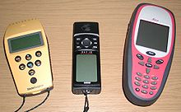
Fig 5.3 User Segment
The user segment is composed of hundreds of thousands of U.S. and allied military users of the secure GPS Precise Positioning Service, and tens of millions of civil, commercial and scientific users of the Standard Positioning Service. In general, GPS receivers are composed of an antenna, tuned to the frequencies transmitted by the satellites, receiver-processors, and a highly stable clock (often a crystal oscillator). They may also include a display for providing location and speed information to the user. A receiver is often described by its number of channels: this signifies how many satellites it can monitor simultaneously. Originally limited to four or five, this has progressively increased over the years so that, as of 2007, receivers typically have between 12 and 20 channels.^{[57]}
N
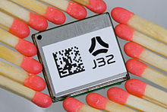

GPS receivers may include an input for differential corrections, using the RTCM SC-104 format. This is typically in the form of an RS-232 port at 4,800 bit/s speed. Data is actually sent at a much lower rate, which limits the accuracy of the signal sent using RTCM. Receivers with internal DGPS receivers can outperform those using external RTCM data. As of 2006, even low-cost units commonly include Wide Area Augmentation System (WAAS) receivers.
Many GPS receivers can relay position data to a PC or other device using the NMEA 0183 protocol. Although this protocol is officially defined by the National Marine Electronics Association (NMEA references to this protocol have been compiled from public records, allowing open source tools like gpsd to read the protocol without violating intellectual property laws. Other proprietary protocols exist as well, such as the SiRF and MTK protocols. Receivers can interface with other devices using methods including a serial connections in GPS

CHAPTER-6
SOFTWARE DESCRIPTION

6.1.About software:

MDK-ARM Keil µVision:
This is free software (evaluation version) which solves many of the pain points for an embedded system developer. This software is an Integrated Development Environment (IDE), which integrated text editor to write program, a compiler and it will convert your source code into HEX file. Here is simple guide to start working with Keil µVision which can be used for:
- Writing programs in C/C++ or Assembly
- Compiling and assembling programs
- Debugging programs
- Creating HEX, AXF and BIN file
- Test program without real hardware
Here is step by step guide to create fresh new project for ARM7 LPC2148 Microcontroller using MDK-ARM µVision4.
- Once we’ve installed Keil, click on Keil µVision4 icon. This will appear on desktop after installation Keil.
- Click on Project menu, and then hit on New uVision Project

Create New Project Keil LPC2148

Create new project folder named as Blinky.
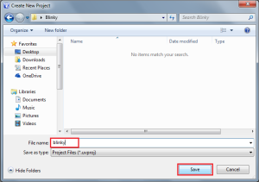
Give Name to New Keil Project

- Select target Device vendor. In this case NXP (founded by Phillips)
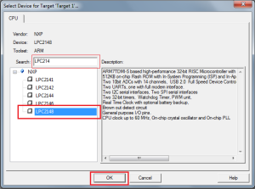
Select Device in Keil
- Expand NXP icon and select specific chip i.e. LPC2148 After this, a dialog box will pop-up on screen. This will ask you whether to copy startup code for LPC2148. Click on Yes.

Add Startup File for LPC2148
- Then we’ll get basic workplace to get start with writing code in. When we expand Target1 in left project pane. We see Startup’s is already added which is necessary for running code in Keil.

Ready Workplace for LPC2148

NOTE:
Code will not run without Start up file. Because startup code executes immediately upon reset of the target system and performs the following listed operations.
- Defines interrupt and exception vectors
- Configures the CPU clock source (on same device)
- Initializes the external bus controller
- Copies the exception vectors from ROM and RAM for systems with memory remapping
- Initializes other low level peripherals, if necessary
- Reserves and initializes the stack for all modes
- Reserves the heap
- Transfers control to the main C function
- Now click on File menu and hit on New.
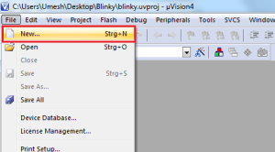
Create New File Keil
- Write code to blink LED in C and Filename Save. NOTE: Don’t forget to save as with .c extension
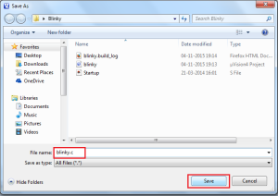
Add C File ToKeil Project
- Once we save file as blinky.c. We’ll quickly get complete code with syntax highlighted.
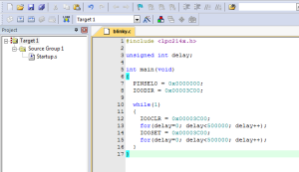
Code Highlighted In Keil LPC2148
- Now we can add blinky.c file by adding it to Group Source 1.
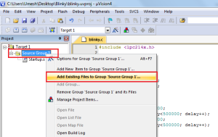
Add Source File to Project LPC2148

- Add blinky.c file
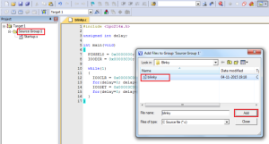
Add File ToKeil Project
- Now right click on Target 1 and hit on Options for target “Target 1”
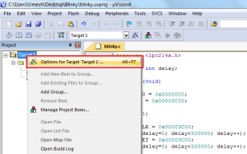
Set Options for Target LPC2148

In Options for target “Target 1”. In output tab, click on check box Create HEX File.
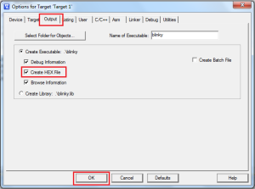
Set Output Keil LPC2148
- Then go to Linker tab. Click on Use Memory Layout for Target Dialog
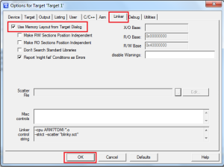
Setup Linker Option Keil LPC2148

- Then hit on Rebuild All target files
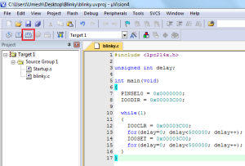
Rebuild theKeil Project LPC2148
- Now we can see Build output. If we check project directory at this point. We’ll find generated HEX file. Later on we’ll use it to load or burn into LPC2148 MCU using Flash Magic.
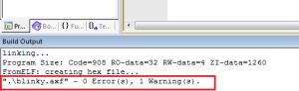
Build Output Keil LPC2148
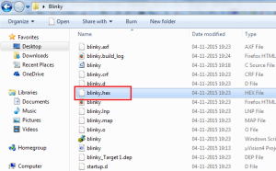
HEX File Generated Using Keil LPC2148

The only part left here is to setup Flash Magic and load HEX file into LPC2148 Microcontroller. Here are some pictures or I recommend you to watch video on this post to see step by step configuration and final output.
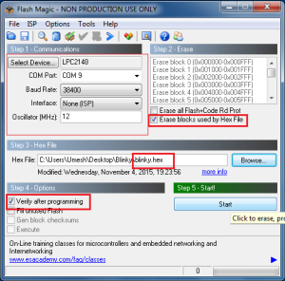
Basic Setting Flash Magic LPC2148
STEP-2
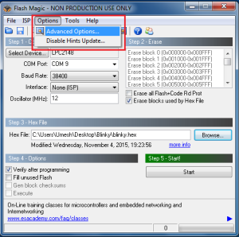
Setup Options for Flash Magic LPC2148

STEP-3
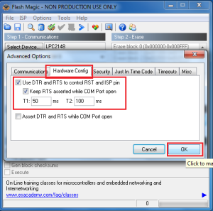
Setup Hardware Configuration Flash Magic
STEP-4 Finally It’s done….!!!!
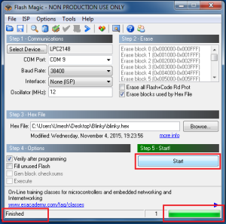Flash Magic Loading Finished LPC2148

RESULT AND CONCLUSION
Vehicle to Vehicle Safety Device is a device indulge with therecent technology and includes the methodology based on the combination of Zigbee, GSM and many other modules by thehelp of which immediate support can be provided to anyone inneed of it. This project is microcontroller based project .As a part of as a part of studying the analysis circuits and programswere simulated on Micro vision 4 Keil, Hardware.
Implementations are done using PCB layouts and EXPRESSPCB. In this paper a brief description is provided by themedium of Block Diagram and Flow diagrams as well as theintroduction of technology. Also the results andimplementation is being discussed here.

APPLICATION & FUTURE WORK

Security
As the new path for vehicle is opened in field ofcommunication, the security for itself and passenger has beenincreased. In case of vehicle lost or theft, one can simply send amessage to it and ask for its location.
B. Safety
Accident alert to nearest help centre road condition warning etc. Come under the safety of passenger. The condition of overtaking accident can be overcome through the vehicle to vehicle communication. Warning of car failure

BIBLOGRAPHY

[1] “The role of ZigBee technology in future data communicationsystem” by Dr.S.S.RiazAhamed.
[2] “Remote Monitoring and Controlling System Based onZigBee Networks” by Soyoung Hwang and Donghui Yu
[3] “Wireless Networking throughZigBeeTechnology” ISSN:2277 128X Step upingZigBee network Communication
[4] “The 8051 microcontroller and embedded system” by Muhammad Ali Mazidi, Janice GillispieMazidi ,RolinD.McKinlay ISBN-13: 978-0131194021.
[5] “V2V COMMUNICATION SURVEY - (WIRELESS TECHNOLOGY)” ISSN: 2229-6093.
[6] “Security Architectures in V2V and V2I Communication” by Rens van der Heijde
[7] Hubaux, J.-P., Capkun, S. and Luo, J. The security and privacy of smart vehicles. IEEE Security and PrivacyMagazine, 2 (3). 49–55.
[8] Enkelmann, W., FleetNet - applications for inter-vehicle communication. In IEEE Intelligent Vehicles Symposium, (2003), 162–167.
[9] Xu, Q., Mak, T., KO, J. and Sengupta, R., Vehicle-to-vehicle safety messaging in DSRC.in Proceedings Of the first ACM workshop on Vehicular ad hoc networks, (2004), ACM Press, 19–28.
[10] Miller, J. M., &Nicastri, P. R. (1998). The next generation automotive electrical power system architecture: Issues and challenges. Proceedings of the 17th digital avionics systems conference, Bellevue, WAUSA, Session I1, Book 5.

